**EE415 – NEW AND RENEWABLE ENERGY SOURCES**

**UNIT-I**

**Renewable Energy Technologies:**

Basic principles of Energy conversion: Heat Energy Conversion Principles – Mechanical Energy Principles – Solar Radiation Conversion: Photovoltaic Conversion – Photo Electro Chemical Conversion – Solar Thermal Conversion – Fuel Cells – Basic Principles of Hydrogen – Oxygen fuel cell – factory effecting the Power output – Maximum Power output Bio Energy Conversion Process – Combustion and composting of Bio- Mass – Production of heat by bio-mass – Bio-logical Conversion into gaseous into liquid bio-fuels.

* 1. **Basic Principles of Energy Conversion**

A large number of energy conversion processes take place in nature. Man is capable of performing additional energy conversion processes by means of various devices he has invented. Such devices may be classified according to the type of construction used, according to the underlying physical or chemical principle, or according to the forms of energy appearing before and after the action of the device. This chapter surveys methods that may be suitable for the conversion of renewable energy flows or stored energy.

|  |  |  |  |  |  |
| --- | --- | --- | --- | --- | --- |
| Initial Energy Form | Converted Energy Form | | | | |
|  | Chemical | Radiant | Electrical | Mechanical | Heat |
| Nuclear |  |  |  |  | Reactor |
| Chemical |  |  | Fuel cell, battery discharge |  | Burner, boiler |
| Radiant | Photolysis |  | Photo voltaic cell |  | Absorber |
| Electrical | Electrolysis, battery charging | Lamp, Laser |  | Electric Motor | Resistance, Heat Pump |
| Mechanical |  |  | Electric generator, MHD | Turbines | Friction, Churning |
| Heat |  |  | Thermionic & thermoelectric generators | Thermodynamic engines | Convector, radiator, heat pipe |

Above table lists some examples of energy conversion processes or devices currently in use or contemplated, organized according to the energy form emerging after the conversion. In several cases, more than one energy form emerges as a result of the action of the device; for example, heat in addition to one of the other energy forms listed. Many devices also perform several energy conversion steps, rather than the single ones given in the table. A power plant, for example, may perform the conversion process chain between the energy forms: chemical → heat → mechanical → electrical. Diagonal transformations are also possible, such as conversion of mechanical energy into mechanical energy (potential energy of elevated fluid → kinetic energy of flowing fluid → rotational energy of turbine) or of heat into heat at a lower temperature (convection, conduction). A process in which the only change is heat transfer from a lower to a higher temperature is forbidden by the second law of thermodynamics. Such transfer can be established if at the same time some high-quality energy is degraded, for example, by a heat pump. The efficiency with which a given conversion process can be carried out, that is, the ratio between the output of the desired energy form and the energy input, depends on the physical and chemical laws governing the process. For heat engines, which convert heat into work or vice versa, the description of thermodynamic theory may be used in order to avoid a complicated description on the molecular level. According to thermodynamic theory (again, the second law), no heat engine can have an efficiency higher than that of a reversible Carnot process.

**1.2 Heat Energy Conversion Principles**

**1.2.1 Direct Thermoelectric Conversion**

1.2.1.1 Thermo Electric Generators

A thermoelectric generator (TEG), also called a Seebeck generator, is a solid state device that converts heat flux (temperature differences) directly into electrical energy through a phenomenon called the Seebeck effect (a form of thermoelectric effect). Thermoelectric generators function like heat engines, but are less bulky and have no moving parts. However, TEGs are typically more expensive and less efficient.

Thermoelectric generators could be used in power plants to convert waste heat into additional electrical power and in automobiles as automotive thermoelectric generators (ATGs) to increase fuel efficiency. Radioisotope thermoelectric generators use radioisotopes to generate the required heat difference to power space probes.

Thermoelectric power generators consist of three major components: thermoelectric materials, thermoelectric modules and thermoelectric systems that interface with the heat source.

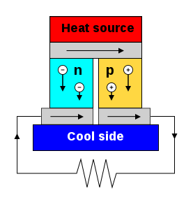

Thermoelectric materials generate power directly from the heat by converting temperature differences into electric voltage. These materials must have both high electrical conductivity (σ) and low thermal conductivity (κ) to be good thermoelectric materials. Having low thermal conductivity ensures that when one side is made hot, the other side stays cold, which helps to generate a large voltage while in a temperature gradient. The measure of the magnitude of electrons flow in response to a temperature difference across that material is given by the Seebeck coefficient (S). The efficiency of a given material to produce a thermoelectric power is governed by its “figure of merit” zT = S2σT/κ.

1.2.1.2 Thermionic Generators

It is the use of electron vapor as the working fluid in a power-producing cycle. A thermionic converter consists of a hot emitter electrode from which electrons are vaporized by thermionic emission and a colder collector electrode into which they are condensed after conduction through the inter-electrode plasma. The resulting current, typically several amperes per square centimeter of emitter surface, delivers electrical power to a load at a typical potential difference of 0.5–1 volt and thermal efficiency of 5–20%, depending on the emitter temperature (1500–2000 K) and mode of operation.

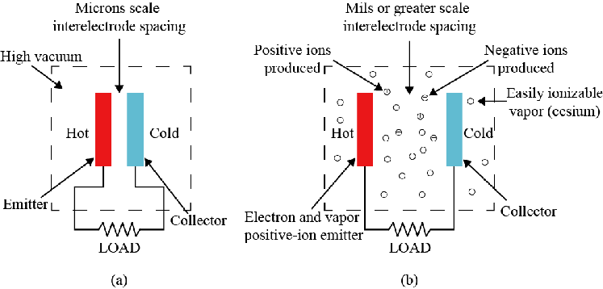

1.2.2 Engine Conversion of Solar Energy

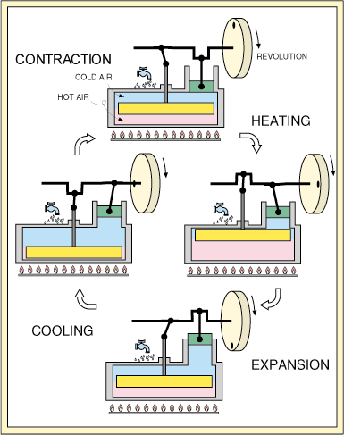

Ericsson hot-air engine, which is based on a gas (usually air) as a working fluid. A displacer type Stirling engine makes working gas go and return between high temperature space and low temperature space by a displacer piston, and output the pressure variation that occurs by this gas movement as power by a power piston.

In the displacement engine there are two pistons. The smaller piston shown in the illustration is the power piston. All of the power for this model is provided by the power piston. The second larger piston is the displacer piston. It's function is to move the air between the hot and the cold sides of the air compartment. It provides no power at all. The power piston for this model should be 90 degrees out of phase from the displacer piston. This model has four simple steps. Begining at the top of the illustration, the first step is heating. The heating is caused by the movement of the displacer piston so that most of the gas is on the hot side. The temperature of the gas subsequently increases, causing an increase in pressure. Because of this increase in pressure there is an expansion of the gas causing the power piston to rise. Then, due to the 90 degree phase shift between the two pistons, the displacer piston is moved, resulting in the cooling of the gas. But when the gas is cooled, the pressure decreases, causing a contraction in the gas, thereby pulling the power piston back down. Then once again, due to the 90 degree phase shift, the displacer piston follows causing the gas to shift to the hot side of the chamber. The temperature of the gas then increases, and we are back to our first step. This is the most basic model of the stirling engine.

1.2.3 Heat Pumps

Heat pumps exploit the physical properties of a volatile evaporating and condensing fluid known as a refrigerant. The heat pump compresses the refrigerant to make it hotter on the side to be warmed, and releases the pressure at the side where heat is absorbed.

The working fluid, in its gaseous state, is pressurized and circulated through the system by a compressor. On the discharge side of the compressor, the now hot and highly pressurized vapor is cooled in a heat exchanger, called a condenser, until it condenses into a high pressure, moderate temperature liquid. The condensed refrigerant then passes through a pressure-lowering device also called a metering device. This may be an expansion valve, capillary tube, or possibly a work-extracting device such as a turbine. The low-pressure liquid refrigerant then enters another heat exchanger, the evaporator, in which the fluid absorbs heat and boils. The refrigerant then returns to the compressor and the cycle is repeated.

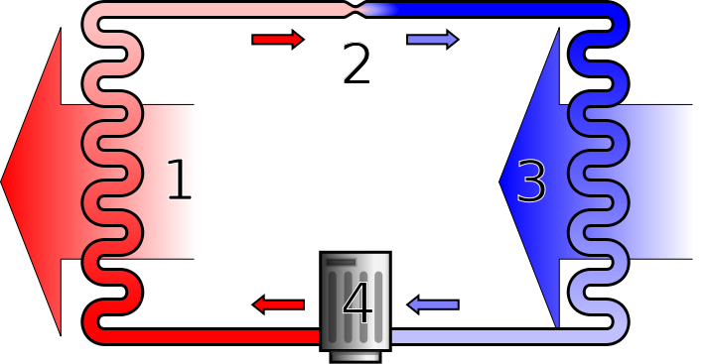

A simple stylized dia gram of a heat pump's vapor-compression refrigeration cycle: 1) condenser, 2) expansion valve, 3) evaporator, 4) compressor

1.2.4 Geothermal - thermal Conversion

Geothermal energy, form of energy conversion in which heat energy from within Earth is captured and harnessed for cooking, bathing, space heating, electrical power generation, and other uses. Heat from Earth’s interior generates surface phenomena such as lava flows, geysers, fumaroles, hot springs, and mud pots. The heat is produced mainly by the radioactive decay of potassium, thorium, and uranium in Earth’s crust and mantle and also by friction generated along the margins of continental plates.

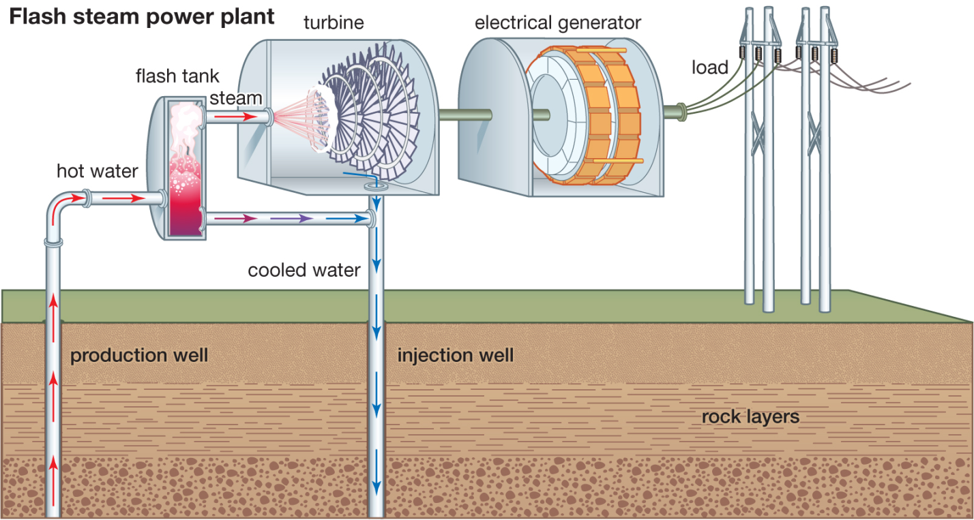

In flash steam power plants, pressurized high-temperature water is drawn from beneath the surface into containers at the surface, called flash tanks, where the sudden decrease in pressure causes the liquid water to “flash,” or vaporize, into steam. The steam is then used to power the turbine-generator set. In contrast, binary-cycle power plants use steam driven off a secondary working fluid (such as ammonia and hydrocarbons) contained within a closed loop of pipes to power the turbine-generator set. In this process, geothermally heated water is drawn up through a different set of pipes, and much of the energy stored in the heated water is transferred to the working fluid through a heat exchanger. The working fluid then vaporizes. After the vapour from the working fluid passes through the turbine, it is recondensed and piped back to the heat exchanger.

1.2.5 Ocean-thermal Conversion

Ocean thermal energy conversion (OTEC) is a process or technology for producing energy by harnessing the temperature differences (thermal gradients) between ocean surface waters and deep ocean waters.

Energy from the sun heats the surface water of the ocean. In tropical regions, surface water can be much warmer than deep water. This temperature difference can be used to produce electricity and to desalinate ocean water. Ocean Thermal Energy Conversion (OTEC) systems use a temperature difference (of at least 77° Fahrenheit) to power a turbine to produce electricity. Warm surface water is pumped through an evaporator containing a working fluid. The vaporized fluid drives a turbine/generator. The vaporized fluid is turned back to a liquid in a condenser cooled with cold ocean water pumped from deeper in the ocean. OTEC systems using seawater as the working fluid can use the condensed water to produce desalinated water.

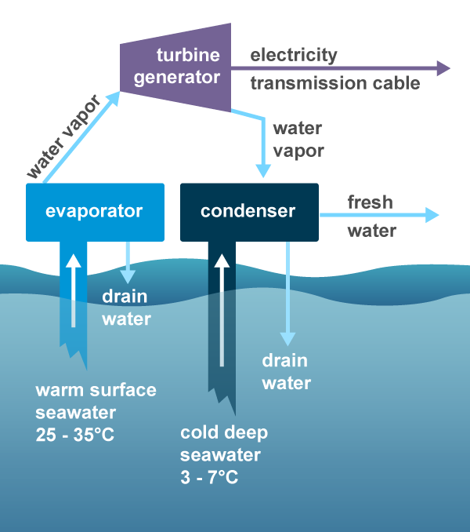

1.3 Mechanical Energy Principles

1.3.1 Basic Description of Flow-driven Converters

A turbine is a device delivering rotational shaft power on the basis of some other type of mechanical energy. The output variables are the angular velocity of the shaft and the torque acting on the system, while the input variables are the mass flow rate and the generalized force

1.3.2 Propeller-type Converters

Propeller-type rotors are used for windmills in which the motion of the air makes the propeller, which should be placed with its axis parallel to the wind direction, rotate, thus providing the possibility of power extraction. The propeller consists of a number of blades that are evenly distributed around the axis with each blade having a suitable aerodynamic profile usually designed to produce a high lift force. If there are two or more blades, the symmetrical mounting ensures a symmetrical mass distribution, but if only one blade is used it must be balanced by a counterweight.

1.3.3 cross-wind type converters

Wind energy converters of the cross-wind type have the rotor axis perpendicular to the wind direction. The rotor axis may be horizontal as in wheel-type converters or vertical as in the panemones used in Iran and China. The blades move with and against the wind direction on alternative sides of the rotor axis, necessitating some way of emphasizing the forces acting on the blades on one side.

1.3.4 Hydro and Tidal Energy Conversion

Electricity generation from water possessing potential, kinetic, or pressure energy can be achieved by means of a turbine. The design of the particular turbine to be used depends on whether there is a flow through the device, which must be kept constant for continuity reasons, or whether it is possible to obtain zero fluid velocity after passage through the turbine. The energy at the entrance of the turbine may be kinetic or pressure energy, causing the forces on the turbine blades to be a combination of “impulse” and “reaction” forces, which can be modified easily. If elevated water is allowed to “fall,” its potential energy forms kinetic energy, or it may act as a pressure source through a water-filled tube connecting the elevated water source with the turbine placed below. Conversely, pressure energy may be transformed into kinetic energy by passage through a nozzle

1.3.5 Magneto hydrodynamic converter (MHD converter)

A magneto hydrodynamic converter (MHD converter) is an electromagnetic machine with no moving parts involving magneto hydrodynamics, the study of the kinetics of electrically conductive fluids (liquid or ionized gas) in the presence of electromagnetic fields. Such converters act on the fluid using the Lorentz force to operate in two possible ways: either as an electric generator called an MHD generator, extracting energy from a fluid in motion; or as an electric motor called an MHD accelerator or magneto hydrodynamic drive, putting a fluid in motion by injecting energy. MHD converters are indeed reversible, like many electromagnetic devices.

1.4 SOLAR RADIATION CONVERSION

1.4.1 Photovoltaic Conversion

The photovoltaic conversion is based on the photovoltaic effect, that is, on the conversion of the light energy coming from the sun into electrical energy. To carry out this conversion, devices called solar cells are used, constituted by semiconductor materials in which a constant electric field has been created artificially (by means of a pn junction).

Working explanation

1. [Photons](https://en.wikipedia.org/wiki/Photon) in [sunlight](https://en.wikipedia.org/wiki/Sunlight) hit the solar panel and are absorbed by semi-conducting materials.
2. [Electrons](https://en.wikipedia.org/wiki/Electrons) (negatively charged) are knocked loose from their atoms as they are excited. Due to their special structure and the materials in solar cells, the electrons are only allowed to move in a single direction. The electronic structure of the materials is very important for the process to work, and often [silicon](https://en.wikipedia.org/wiki/Silicon) incorporating small amounts of [boron](https://en.wikipedia.org/wiki/Boron) or [phosphorus](https://en.wikipedia.org/wiki/Phosphorus) is used in different layers.
3. An array of solar cells converts solar energy into a usable amount of [direct current](https://en.wikipedia.org/wiki/Direct_current) (DC) electricity.

1.4.2 Photo-electrochemical Conversion

A "photo-electro-chemical cell" is also known as photo-electrolytic cell, that is, a device which uses light incident on a photo sensitizer, semiconductor, or aqueous metal immersed in an electrolytic solution to directly cause a chemical reaction, for example to produce hydrogen via the electrolysis of water.

The situation in a water-splitting photo-electro-chemical cell, the excitation, by light, of an electron in a semiconductor leaves a hole which "draws" an electron from a neighbouring water molecule:



This leaves positive charge carriers (protons, that is, H+ ions) in solution, which must then bond with one other proton and combine with two electrons in order to form hydrogen gas, according to:

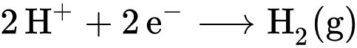

1.4.3 Solar Thermal Conversion

Solar thermal energy (STE) is a form of energy and a technology for harnessing solar energy to generate thermal energy or electrical energy for use in industry, and in the residential and commercial sectors.

Solar thermal collectors are classified as low-, medium-, or high-temperature collectors. Low-temperature collectors are generally unglazed and used to heat swimming pools or to heat ventilation air. Medium-temperature collectors are also usually flat plates but are used for heating water or air for residential and commercial use.

High-temperature collectors concentrate sunlight using mirrors or lenses and are generally used for fulfilling heat requirements up to 300 deg C / 20 bar pressure in industries, and for electric power production. Two categories include Concentrated Solar Thermal (CST) for fulfilling heat requirements in industries, and Concentrated Solar Power (CSP) when the heat collected is used for power generation. CST and CSP are not replaceable in terms of application.

4.5 ELECTROCHEMICAL ENERGY CONVERSION

Electrochemical energy conversion is the direct conversion of chemical energy into electrical power or vice versa. A device that converts chemical energy into electric energy is called a fuel cell. A device that accomplishes the inverse conversion (e.g., electrolysis of water into hydrogen and oxygen) may be called a driven cell.

4.5.1 Fuel Cells

A fuel cell is an electrochemical device that converts the chemical energy of a fuel directly into electrical energy.

Basic Principles of Hydrogen – Oxygen fuel cell

A fuel cell is composed of three active components: a fuel electrode (anode), an oxidant electrode (cathode), and an electrolyte sandwiched between them. The electrodes consist of a porous material that is covered with a layer of catalyst (often platinum in PEMFCs). Fig. illustrates the basic operational processes within a typical PEMFC. Molecular hydrogen (H2) is delivered from a gas-flow stream to the anode where it reacts electrochemically. The hydrogen is oxidized to produce hydrogen ions and electrons, as shown in Fig., per the following equation:



The hydrogen ions migrate through the acidic electrolyte while the electrons are forced through an external circuit all the way to the cathode. At the cathode, the electrons and the hydrogen ions react with the oxygen supplied from an external gas-flow stream to form water, as shown in Fig., per the following equation:

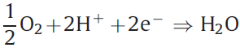

The overall reaction in the fuel cell produces water, heat, and electrical work as follows:

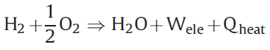

The heat and water by-products must be continuously removed in order to maintain continuous isothermal operation for ideal electric power generation. Hence, water and thermal management are key areas in the efficient design and operation of fuel cells.

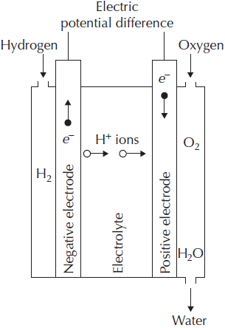

Factors effecting the Power output – Maximum Power output

In actual fuel cells, a number of factors tend to diminish the power output. They may be expressed in terms of “expenditure” of cell potential fractions on processes not contributing to the external potential,

Δϕext = ϕ −ϕ1 −ϕ2 − ϕ3 − …,

Where each of the terms −ϕi corresponds to a specific loss mechanism. Examples of loss mechanisms are blocking of pores in the porous electrodes, internal resistance of the cell (heat loss), and the build-up of potential barriers at or near the electrolyte–electrode interfaces. Most of these mechanisms limit the reaction rates and thus tend to place a limit on the current of ions that may flow through the cell. There will be a limiting current, IL, beyond which it will not be possible to draw any more ions through the electrolyte, because of either the finite diffusion constant in the electrolyte, if the ion transport is dominated by diffusion, or the finite effective surface of the electrodes at which the ions are formed.

It follows that there will be an optimum current, usually lower than IL, for which the power output will be maximal,

Max(E) = Iopt Δϕoptext

4.6 BIOENERGY CONVERSION PROCESSES

Biomass is plant or animal material used for energy production (electricity or heat), or in various industrial processes as raw substance for a range of products. It can be purposely grown energy crops (e.g. miscanthus, switchgrass), wood or forest residues, waste from food crops (wheat straw, bagasse), horticulture (yard waste), food processing (corn cobs), animal farming (manure, rich in nitrogen and phosphorus), or human waste from sewage plants.

**4.6.1 Direct combustion for production of heat**

Biomass is burnt to provide heat for cooking, comfort heat (space heat), crop drying, factory processes and raising steam for electricity production and transport. Traditional use of biomass combustion includes (a) cooking with firewood, with the latter supplying about 10–20% of global energy use (a proportion extremely difficult to assess) and (b) commercial and industrial use for heat and power, e.g. for sugarcane milling, tea or copra drying, oil palm processing and paper making. Efficiency and minimum pollution is aided by having dry fuel and controlled, high temperature combustion.

Biomass direct combustion is not only the oldest form of combustion used by humanity but it is also one of the most complex combustion systems to manage. The main biomass for combustion is wood which has been used over the years. It is burnt to provide heat for cooking, comfort heat (space heat), crop drying. factory processes and farming steam for electricity production and transport.

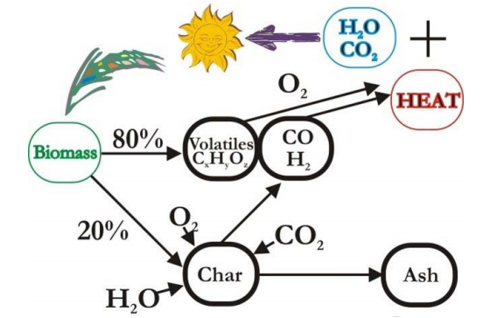

As direct combustion involves the use of solid fuels in a multi phase reaction system with extensive interaction between thermal and mass fluxes, these processes have only recently been properly analyzed to design efficient combustion systems.

The key to understanding solid fuel combustion processes is to recognize that only fuel gases burn and release heat, that liquids and the solids do not burn themselves, but actually consume heat in the drying and volatilization processes needed for them to be chemically converted into fuel gases. The main fuel intermediates are the volatile hydrocarbons and energy rich organic molecules, carbon monoxide (CO) and hydrogen (H2).

4.6.6 Composting of Bio Mass

The process of composting requires making a heap of wet organic matter (also called green waste), such as leaves, grass, and food scraps, and waiting for the materials to break down into humus after a period of months. However, composting can also take place as a multi-step, closely monitored process with measured inputs of water, air, and carbon- and nitrogen-rich materials. The decomposition process is aided by shredding the plant matter, adding water and ensuring proper aeration by regularly turning the mixture when open piles or "windrows" are used. Fungi, earthworms and other detritivores further break up the material. Aerobic bacteria and fungi manage the chemical process by converting the inputs into heat, carbon dioxide, and ammonium.

4.6.7 Bio-logical Conversion into gaseous Fuels

Gasification of biomass is thermal decomposition in the presence of controlled air. It is the conversion process of solid and carbanacious fuels into combustible gas mixtures known as producer gas. It is also referred to as wood gas, water gas and synthesis gas. This gas can be burned directly in a furnace to generate process heat for electricity generation. Alternative fuel from biomass is prepared through a gasification process in gaseous form which substitutes for fuel in internal combustion engine. Due to the flexibility of application of producer gas, gasification has been proposed as the basis for energy refineries. It would provide a variety of energy and chemical products including electricity and transportation fuels.

Gasification is the partial combustion of biomass that occurs when the air supply is less than adequate for combustion of biomass to be completed. Biomass contains carbon, hydrogen and oxygen molecules for complete combustion to produce carbon dioxide (CO2) and water vapour (H2O). Partial combustion produces carbon monoxide (CO) as well as hydrogen (H2) which are both combustible gases.

By weight, wood gas or producer gas obtained from the charring wood contains approximately 10-20% hydrogen (Hz), 15-30% carbon monoxide (CO) and small amount of methane, All are combustible. It also contains 45-60% noncombustible nitrogen (N),

Steam gasification:

Methane is directly produced from woody matter By treating ot high temperature and pressure with hydrogen gas. The hydrogen can be added or more commonly generated in the reactor vessel from carbon monoxide and steam.

4.6.7 Bio-logical Conversion into liquid Fuels

In the liquefaction process, liquid yields are maximized by rapid heating of fed stock to comparatively low temperature. The vapour is condensed from the gas stream and they are separated into two-phase liquor. They are as follows:

1. Aqueous phase (pyroligneous acid)

2. Nonaqueous phase

The aqueous phase contains organic materials such as acetic acid, acetone and methanol. The non-aqueous phase-consists of oils and tars. Liquefaction of biomass can be achieved through two processes.

(a) Liquefaction through pyrolysis without any gasification medium and

(b) Liquefaction through methanol synthesis with gasification medium.

(a) Liquefaction through pyrolysis:

As mentioned earlier, pyrolysis is the thermal decomposition of organic compounds in the absence of air. The resulting product streams depend on the rate and duration of heating. Liquid yields exceeding 70% are produced under fast pyrolysis conditions. It is characterised as having short residence time (< 0.5 s) at moderate temperatures of 450 to 600 °C and rapid quenching at the end of the process. Rapid quenching is essential if high molecular weight liquids are to be condensed rather than further decomposed to low molecular weight gases.

Pyrolysis liquid from fast pyrolysis is a low viscosity, dark brown fluid up to 15 to 20% water. It contrasts with the black, tarry liquid resulting from slow pyrolysis. Fast pyrolysis liquid is a complicated mixture of hydrocarbons arising from the uncontrolled degradation of lignin in lignocelluloses biomass. The liquid is highly oxygenated which makes it highly unstable. It contains many different compounds, namely phenols, sugars and both aliphatic and aromatic hydrocarbons. The low pH of pyrolysis liquids makes the liquids highly corrosive. The liquid also contains particulate char. The higher heating values of pyrolysis liquids are ranging from 17 MJ/kg to 20 MJ/kg with liquid densities of about 1280 kg/m3.

Pyrolysis liquids can be used directly as a substitute for heating oil. In some cases, they are also suitable as fuel for combustion turbines or modified diesel engines. However, there are several problems with pyrolysis liquids. The storage of these liquids becomes difficult due to phase separation and polymerisation of liquids and corrosion of containers. The high oxygen and moisture content of pyrolysis liquids makes them incompatible with conventional hydrocarbon fuels.

(b) Liquefaction through methanol synthesis

Methanol is a liquid fuel that can be burned in a modified internal combustion engines. It is also known as methyl alcohol.

Methanol (CH3OH) produced by the reaction of CO and H2 at 330°C and 150 atmospheric pressure is given by

ΔH = -90.77 kJ/mol

The CO and H2 are required for this process. It can be produced by gasifying biomass fuels. Gasification often produces less hydrogen than the 2:1 ratio of H2 to CO for methanol synthesis. Thus, the gas mixture (producer gas Synthesis gas) is often reacted with steam in the presence of a catalyst to promote a shift to higher hydrogen content as

ΔH = -40.57KJ/mol

CO2 and H2S in the synthesis gas are removed prior to the methanol reactor, The gas reacts with a catalyst at elevated temperature and pressure to produce methanol in a highly exothermic reaction.

The yields of methanol from woody biomass are expected to be in the range of 480-568 lit/ton. Methanol can be used as a liquid fuel in petroleum engines. It has an energy density of 23 MJ/kg. Variations in methanol yield from different biomass feedstocks are expected to be relatively small.